

**Building Your**

Theology

­­

Manuscript

What is Theology?

Lesson 1

© 2004, 2020 by Third Millennium Ministries

All rights reserved. No part of this publication may be reproduced in any form or by any means for profit, except in brief quotations for the purposes of review, comment, or scholarship, without written permission from the publisher, Third Millennium Ministries, Inc., 316 Live Oaks Blvd., Casselberry, Florida 32707.

Unless otherwise indicated, all Scripture quotations are from The Holy Bible, English Standard Version® (ESV®), copyright © 2001 by Crossway, a publishing ministry of Good News Publishers. Used by permission. All rights reserved.

**About Thirdmill**

Founded in 1997, Thirdmill is a non-profit Evangelical Christian ministry dedicated to providing:

**Biblical Education. For the World. For Free.**

Our goal is to offer free Christian education to millions of pastors and Christian leaders worldwide who lack sufficient training for ministry. We are meeting this goal by producing and globally distributing an unparalleled multimedia seminary curriculum in English, Arabic, Chinese, Russian, and Spanish. Our partner ministries are also translating our curriculum into more than 20 additional languages. Consisting of graphic-driven videos, printed instruction, and internet resources, Thirdmill curriculum is designed to be used by schools, groups, and individuals, both online and in local learning communities. We also offer free, structured, certified biblical and theological training in multiple languages through our Thirdmill Institute.

Over the years, we have developed a highly cost-effective method of producing multimedia lessons of the finest content and quality. Our graphic designers, illustrators, and producers adhere to the highest production standards and use state-of-the-art equipment and techniques. Our writers and editors are theologically trained educators, our translators are theologically astute native speakers of their target languages, and our lessons contain the insights of hundreds of respected seminary professors and pastors from around the world.

In order to accomplish our distribution goals, Thirdmill has forged strategic partnerships with churches, seminaries, Bible schools, missionaries, Christian broadcasters, satellite television providers, and other organizations. These relationships have already resulted in the distribution of millions of video lessons to indigenous leaders, pastors, and seminary students. Our websites also serve as avenues of distribution and provide additional materials to supplement our lessons, including audio sermons, lectures, electronic books, and materials on how to start your own learning community.

Thirdmill is recognized by the IRS as a 501(c)(3) corporation. We depend on the generous, tax-deductible contributions of churches, foundations, businesses, and individuals. For more information about our ministry, and to learn how you can get involved, please visit [www.thirdmill.org](http://www.thirdmill.org).

**Contents**

INTRODUCTION 1

DEFINITIONS 1

Typical Definitions 2

Thomas Aquinas 2

Charles Hodge 3

William Ames 5

John Frame 5

Tendencies 6

Academic Orientation 7

Life Orientation 7

Evaluations 9

Academic Orientation 9

Life Orientation 11

GOALS 13

Primary Goals 13

Orthodoxy 14

Orthopraxis 15

Orthopathos 17

Interdependence 19

Orthodoxy 19

Orthopraxis 20

Orthopathos 21

Priorities 23

TOPICS 26

Options 26

Selections 27

CONCLUSION 29

CONTRIBUTORS 30

GLOSSARY 32

INTRODUCTION

At one time or another, most of us have seen young children build things. Usually, children don’t make elaborate plans. They simply piece things together as seems best at the moment. But when adults build things, like homes or other buildings, they understand how important it is to have a reliable plan and to execute that plan as carefully as possible.

In many ways, the same ought to be true when followers of Christ build their theology. Theology isn’t child’s play. We live, work and worship every day of our lives within the structures that Christian theology provides. And for this reason, it’s important to have a reliable plan and to execute that plan as carefully as possible as we build our Christian theology.

This is the first lesson in our series *Building Your Theology*. In this series, we’ll explore some of the basic directions we should follow to construct a responsible theology — one that honors God and furthers his purposes for our lives. This lesson is entitled “What is Theology?” Our answer to this question will touch on some essential considerations we must keep in mind as we study and live out Christian theology.

Our lesson will divide into three main parts. First, we’ll look at the definitions of theology. Second, we’ll explore the goals of theology. And third, we’ll touch on the topics of theology. Let’s begin by defining what we mean by the term “theology.”

DEFINITIONS

Christians use the word “theology” so much that you might think we all agree on what it means. But throughout the centuries leading theologians have promoted different concepts of Christian theology. The word itself derives from ancient Greek philosophy before the days of Jesus, but it never appears in the Scriptures. It isn’t found in the Septuagint — the ancient Greek translation of the Old Testament — nor does it appear in the New Testament. This is probably because the word “theology” had pagan connotations that were unacceptable to early believers. Even so, Christians began to adopt the term “theology” not long after the time of the New Testament, and it’s become a regular term in our Christian vocabulary today. Of course, throughout the millennia, we’ve understood what it means in different ways. So, it’s important to clarify from the outset the concept of theology that we will follow in this series.

We’ll discuss the definitions of theology in three ways. First, we’ll introduce four typical definitions. Second, we’ll describe the tendencies that these definitions exemplify. And third, we’ll touch on some evaluations of the strengths and weaknesses of these tendencies. Let’s get started by noting four typical definitions of the term “theology.”

Typical Definitions

According to Romans 1, there’s a sense in which all human beings are involved with theology every day of their lives. Here, Paul explained that, from the beginning, God’s invisible attributes and his moral requirements have been revealed to the human race through creation. When confronted with God’s revelation in creation, even unbelievers, however unconsciously at times, reflect on God and his just requirements. And believers, no matter when or where they live, spend much of their time with thoughts of God. Yet, in this series, we want to focus on theology as a more formal task — a task performed by people who make a concerted and well-informed effort to pursue theology as a discipline of study.

There are countless ways that both Christians and non-Christians have defined the formal discipline of theology. But for our purposes here, we’ll limit ourselves to just a sampling of typical definitions from four respected Christian theologians: Thomas Aquinas, Charles Hodge, William Ames and the contemporary theologian John Frame. Consider first how Thomas Aquinas defined theology.

Thomas Aquinas

Thomas Aquinas, the renowned Roman Catholic theologian who lived from around 1225 to 1274, represents a very traditional definition of theology. His outlooks grew out of the practices of theologians who lived before him, and his views continue to influence theologians in many branches of the church, even today.

Thomas is a huge inspiration to me, because Thomas models for us how we could approach, on the one hand, the sacred texts of Scripture and the teachings of Christianity and the desire to be faithful to this, and at the same time all of the input, all of the data, all of the research, all of the movements in mainstream philosophy and science of your day as well. Thomas was known as the great synthesizer because of the way he brought Aristotelian thought and Christian thought together, which at the time, nobody thought you could do that. Aristotle had kind of been forgotten about. He’d been reintroduced to the western world through the Arabs who’d translated him into Latin so that everybody could read him again. And when Aristotle was rediscovered, there was a bit of a panic in Christendom at this moment because everybody recognized that Aristotle was a genius. He was brilliant. He had written on everything, I mean, literally everything. And then, thirdly, it looked like everything Aristotle was saying was at odds with Christianity, and that, therefore, could somehow disprove Christianity. And along comes Thomas who takes this stuff very, very seriously — this philosophy, very, very seriously — and at the same time he maintains his orthodoxy. He maintains a strong, deep, not just *ideological* commitment to Christianity, but a *spiritual* commitment to Christianity as well. And he begins working on the intersection between these two.

— Dr. James K. Dew, Jr.

In Part 1, Question 1, Article 7 of his well-known *Summa Theologica*, Aquinas called theology “sacred doctrine” and defined it as:

[a unified] science [in which] all things are treated under the aspect of God: either because they are God Himself or because they refer to God

Two dimensions of this definition deserve special attention. Notice first that Aquinas identified theology as a “science.”

Now, here, Aquinas didn’t refer to science in the modern sense of the word. Rather, he used the term “science” in the older and broader sense of “an intellectual or scholarly pursuit.” In this sense, theology is an academic task with a rather specific goal. Much like people study biology, psychology, literature, law or history, theologians pursue theology as an academic discipline.

In Aquinas’ view, the theologian’s task was primarily to think, speak or write about doctrines or concepts. Of course, Aquinas believed that theology should have practical influences on every dimension of the Christian life. But he primarily conceived of theology as a science, an intellectual pursuit.

In addition to theology being a unified science, Aquinas determined that the discipline of theology focuses on two main subjects. On the one hand, theologians address issues pertaining to “God himself.”

For instance, theologians formulate what they believe about matters such as the attributes of God — his omniscience, his omnipresence, his holiness and the like — as well as his plan and works. We often call these and similar topics the study of “theology proper.” God himself is the object we study.

On the other hand, for Aquinas, the discipline of theology is also the study of other subjects in ways that “*refer to* God.” These subjects are often discussed in other disciplines without reference to God, but theologians study them *in relation to* God. For instance, eschatology, the study of last things, is an important subject in what we may call “general theology.” And Christian teachings about the nature of human beings, evil and sin, redemption, and similar topics all fall under the rubric of theology as well, even though they’re not theology proper.

With Aquinas’ typical definition of theology in mind, let’s consider a similar point of view from the Protestant theologian Charles Hodge, who lived from 1797 to 1878.

Charles Hodge

Although Protestant theologians have differed from their Roman Catholic counterparts in many ways, by and large, they haven’t greatly altered the basic definition of theology. Charles Hodge of Princeton defined theology in the Introduction to his *Systematic Theology*, chapter 2, section 1, as:

the science of the facts of divine revelation so far as those facts concern the nature of God and our relation to him

We can see here that Hodge’s definition is very similar to Aquinas’ definition. Both Aquinas and Hodge described theology as a “science.” Like Aquinas, Hodge viewed theology mainly as an academic discipline. In fact, he even went so far as to use the methods of natural or physical science in his day as a model for theologians to follow. Listen to the way Hodge compared theology with natural science in the Introduction of *Systematic Theology*, chapter 1, section 1:

The Bible is no more a system of theology than nature is a system of chemistry or of mechanics. We find in nature the facts which the chemist or the mechanical philosopher has to examine … to ascertain the laws by which they are determined. So, the Bible contains the truths which the theologian has to collect, authenticate, arrange, and exhibit in their internal relation to each other.

Charles Hodge, *Systematic Theology*

Charles Hodge was a man of the 1800s, and in the 1800s the word “science” was used more broadly than it is today. To modern ears the idea of theology as a science sounds jarring because we think of science as the hard sciences. But in the 1800s science was an organized, systematic, focused body of knowledge that was focused on a particular area of inquiry. So, Hodge opens his systematic theology by referring to sciences in his day, such as history, science of geography. We wouldn’t think of those as sciences today, but in his day, they were sciences. Also, in his day, science and the scientific method had accomplished so very much in the century before him that it was very much esteemed as a method for gaining knowledge. But in addition to that, he wanted to emphasize that theology is the organization of facts; it’s not simply the accumulation of facts. So, just like in astronomy, an astronomer doesn’t simply look at the celestial bodies and make a list of facts about them. He or she tries to organize those facts into a coherent system, and that is astronomy. In theology, the theologian looks at the facts of the Bible and doesn’t just list the facts of the Bible, but takes those facts of the Bible and organizes them into a system so that we can appreciate the interrelatedness of all those facts each to the others.

— Dr. Larry Trotter

For Hodge, the task of the theologian was to approach the Bible much like a scientist approaches nature. He was to gather, analyze and organize the facts of Scripture. Now, Hodge also believed that theology should be applied to Christian living. But, like Aquinas, Hodge didn’t see this as the central focus of formal theology. Rather, he tended to leave application in the hands of ministers and pastors, limiting the actual work of formal theology largely to academics and scholars.

In addition to describing theology as a science, Hodge also claimed that there were two main topics in theology: first, the “nature of God” and second, “our relation to him.” This twofold division of theology is similar to Aquinas’ distinction between theology proper and general theology.

Having seen the typical definitions of theology in Aquinas and Hodge, it will be helpful to look at a third viewpoint. William Ames, an influential Puritan who lived from 1576 to 1633, characterized the task of theology in a strikingly different way.

William Ames

In the opening section of his book, *The* *Marrow of Theology,* Ames wrote that theology should focus on:

the doctrine or teaching of living to God

Now, it’s clear from Ames’ writings that his views reflected traditional outlooks on theology. As he put it here, theology is “doctrine or teaching” — the intellectual pursuit of ideas. But it’s important to note that he did *not* refer to theology as a “science.” Rather, he de-emphasized the close association of theology with other academic disciplines suggested by the language in Aquinas and Hodge. Instead, he identified the marrow of theology — theology’s most central focus — as “living to God.”

Aquinas, and to some extent Hodge, focused on theology as a collection of facts and ideas. But for Ames, the goal of all theological endeavors involved how to live in service to God. Instead of limiting theology primarily to an intellectual, factual pursuit, Ames looked with an experiential — or what the Puritans called “experimental” — orientation toward theology. In Ames view, the most significant dimension of theology is a focus on the full range of the believer’s life before God.

With the views of Aquinas, Hodge and Ames in mind, let’s consider a fourth typical definition offered by the contemporary theologian John Frame.

John Frame

In chapter 3 of his book, *The Doctrine of the Knowledge of God,* Frame defined theology as:

the application of the Word of God by persons to all areas of life

Now, elsewhere Frame affirmed that theology involves the intellectual pursuit of Christian teaching or doctrine. But here Frame stressed that theology is the “application” of God’s Word to “all areas of life.”

For Frame, theology is not merely thinking about a set of traditional, relatively academic issues. Instead, like Ames, Frame sees theology as application. Applying the Scriptures to life is the centerpiece of all Christian theological work.

Theology really can go a couple of different directions. It can go in the path of academic pursuit, and that can be a legitimate and important thing. It can go in the direction of application to life. Part of what’s interesting is people tend to choose between those and pit them against one another. Within the church there is rightly an emphasis on application to life, so we want to know not just information, we want to know how it applies to your life. That’s good and legitimate and ultimately the right end of this theology — how we enjoy God, how we worship him, how we obey him in this world. When we emphasize that, we can say, “Why would academic theology have any importance to us?” But actually, it can have importance because it can help keep us honest. The reality is, we can take the Scriptures and try and apply them and say, “Here’s theology, and here’s how it applies to your life.” But what if we have the theology wrong? What if we’re saying things that historically, biblically, linguistically are just not true? So, the academic is a fancy way of just saying, it’s a legitimate discipline to do theology. Another way sometimes as theologians we talk about it is, good theology is public theology. It’s open for critique. It’s open for feedback because we want to make sure we’re not worshiping an idol but the living God, that that, then, for that *good* theology, can shape our lives. So, it’s got to be about application, but it’s appropriate for us to be rigorous and careful in our reflections.

— Dr. Kelly M. Kapic

As we’ve just seen, these typical definitions of theology have similarities. But they also reflect two distinct emphases or tendencies in the field of formal theology.

Tendencies

To unpack these tendencies, we’ll consider first what we may call the academic orientation in theology. Then we’ll look at the life orientation that some theologians have taken toward their discipline. Let’s start with an academic orientation.

Academic Orientation

On the one side, Aquinas and Hodge represent an academic orientation in theology. Their outlooks reflect the majority of Christian theologians’ views. In simple terms, they define theology in ways that correspond to the etymology, or linguistic background, of the word itself. “Theology” derives from two Greek words: *theos* (θεός)*,* meaning “God,” and *logos* (λόγος), meaning “doctrine or study.” So, the etymology of the word suggests that theology is “the doctrine or study of God.” This academic understanding of theology characterizes the vast majority of formal theological works, both in the past and today.



Academic Orientation

Aquinas

Hodge

Of course, there’s hardly a sincere Christian theologian who would say that merely studying about God and other topics in relation to God should be an end in itself. Faithful Christians affirm that theology is supposed to be applied to their lives in one way or another. But in this dominant, traditional outlook, application to the daily lives of believers is not seen as primary. Rather, it’s a secondary enterprise — often called “practical theology” — that we do *after* we’ve settled scholarly, academic issues in formal theology. As a result, formal theology often can be performed with very little concern for ordinary living. It remains an area in which only a few academically-gifted people can involve themselves to any significant degree. And a sort of culture of intellectual expertise develops in theology.

Now on the other side, rather than a tendency toward an academic orientation in theology, some theologians approach theology with a life orientation.

Life Orientation

Ames and Frame represent this important minority view in which applying theology to the practicalities of life isn’t a secondary task. Rather, it’s the essence of theological reflection in the Christian faith.

Of course, throughout the centuries, there have been theologians who have seen theology as inextricably tied to the broader range of living as a believer. But in the past, relatively few *leading* theologians held this view. In recent decades, however, more and more Christian theologians have begun to reject the concept that theology should be concerned *simply* with intellectual matters. They’ve argued against formal theology as just an academic or conceptual basis for Christian living, but rather as a discipline that is deeply and essentially concerned with living for Christ.

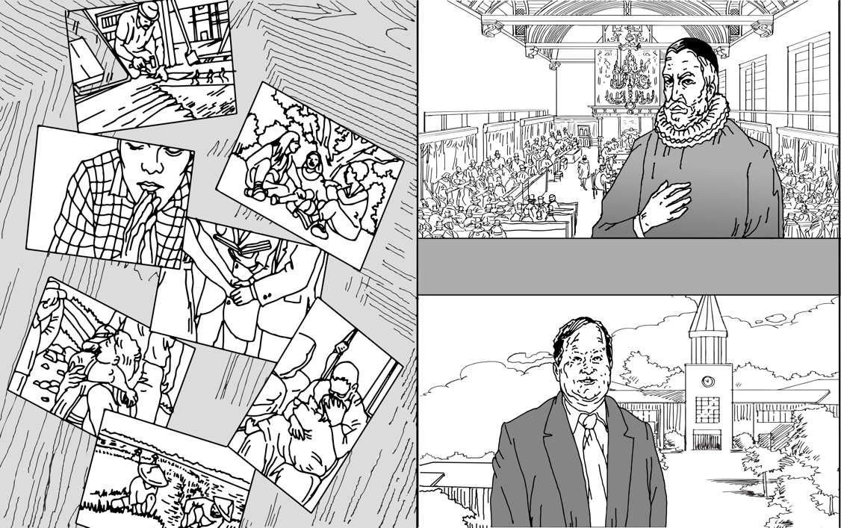

Life Orientation

Ames

Frame

As theologians have carefully reflected on the Scriptures, they’ve come to realize more clearly that love, devotion and service to Christ entail every aspect of our lives, not simply how we *think* about things. This biblical teaching has become increasingly significant in recent decades because scholars in nearly every field of study have begun to acknowledge how much life experiences influence their academic fields. Even the most gifted scholars in the world cannot escape the influence of their cultures and life experiences. And the same is true when it comes to formal theology. We’re constantly reminded these days of the humanity of intellectuals and how their personal lives can deeply influence their academic pursuits.

For example, scientists and medical professionals, who were once thought to be purely objective, are now seen as ordinary people. We regularly question their opinions in ways that would have been unimaginable just a few decades ago. And, in much the same way, the church now recognizes more clearly that no matter how brilliant theologians may be, they are still mere humans. As much as they may claim to be objective observers of the facts, their views are deeply affected by their life experiences. As a result, purely academic approaches to theology are valued much less today, and the need for application is seen much more clearly than before.

So far, we’ve touched on four typical definitions of theology and two important tendencies that they represent. Now, we should step back and offer some evaluations of these tendencies.

Evaluations

Many of us have heard the adage, “Our greatest strength can also be our greatest weakness.” And we all know what this means. Our beliefs, our attitudes and our actions can be of great value to us, but if we aren’t careful, they can also hurt us. In many ways, both academic and life orientations in theology offer many benefits, but they also have the potential for harm. For this reason, we should take a few moments to evaluate both of these theological orientations.

As we make our evaluations, we’ll be looking at the advantages and disadvantages of both an academic orientation and a life orientation in the formal discipline of theology. Let’s start with an academic orientation.

Academic Orientation

Perhaps the greatest advantage or strength of academic approaches to theology is that they emphasize one of God’s most wondrous gifts to humanity: our rational abilities. God has granted human beings intellectual capacities, and he expects theologians to exercise those abilities as they pursue theological truths.

Throughout Scripture, wise men are honored for using their intellectual abilities in service to God. The Bible shows us that to be wise is to ponder what is true and to formulate sets of coherent beliefs out of those rational enquiries. For instance, Solomon was considered wise because he exercised his ability to think through matters. Listen to the high praise given to Solomon in 1 Kings 4:29-31:

God gave Solomon wisdom and understanding beyond measure, and breadth of mind like the sand on the seashore … For he was wiser than all other men … and his fame was in all the surrounding nations (1 Kings 4:29-31).

Similarly, the wisdom literature of the Bible repeatedly calls on faithful believers to develop and use their reasoning abilities.

God has generally and graciously revealed himself to us in so many ways, so we can actually understand God and who he is and what he wants from us, maybe through what people preach to us and through reading the Scriptures as well. So that is there… That doesn’t mean that we don’t need to use our intellectual faculties to understand the Christian faith. Now, if you look at Paul, when he met the philosophers in Acts 17, he actually used his intellectual capabilities to be able to convince them about what he believes, and through that he was able to win some people over to the Lord. And I think we also need to actually use our intellectual faculties to understand the Christian faith, first, so that we can understand God and what he has revealed about himself, so that we can have a meaningful relationship with him. And number two, so that when anybody asks us about our faith, we’ll be in a good position, whether a philosopher or whoever that person may be, we’ll be in a good position to explain our Christian faith to that person like Paul did. So, I think it is very, very important for us to use our intellectual faculties, or the gift that God has given us to reason, to be able to understand our Christian faith.

— Rev. Dr. Humphrey Akogyeram

Learning theology formally and systematically is so important for both the church and the believers to grow, through understanding Scripture and the Christian doctrines. The church usually doesn’t cover these subjects, and we need to train people who can study the Word of God and teach it to others in order to create a generation capable of bearing the message and the depth of teaching God’s Word to others, through their training, evangelism, relationship with the church, and especially, the relationship between the church and the society.

— Rev. Azar Ajaj, translation

Peter acknowledged the importance of intellectual sophistication in 2 Peter 3:15‑16 when he commented on the theology of the apostle Paul. He noted:

Our beloved brother Paul also wrote to you according to the wisdom given him … There are some things in [his letters] that are hard to understand (2 Peter 3:15-16).

As we can see, the intellectual or academic emphasis of traditional theology doesn’t oppose the biblical notion of good theology. On the contrary, rigorous thinking is a great strength of traditional theology.

Still, as valuable as academic orientations toward theology may be, we must always be alert to the dangers they pose. All too often, theologians gather, analyze and collate facts about God with remarkable skill, but they fail to give the same careful attention to *living* in service to God.Sophisticated, rational theological analysis often becomes an end in itself. We commonly consider people to be “good theologians” simply because they know a lot about theological subjects. But at times we have to admit that good theologians are not always good people.

How do we get to the point where someone can be a good theologian but not be a good person? It’s when we operate with a definition of theology that merely includes academic activities, when we think that doing theology means studying well, writing well, and teaching true ideas.

It’s quite possible to be a good theologian, or called a good theologian, and not be a good person. In fact, it happens all too often that people write really great books, they preach great sermons, they’re leaders of the church, and then we find out that they really weren’t good people all along. It happens far too much. And it does happen because often we identify a good theologian with somebody who’s smart and who can be rigorous in their thinking, and we don’t consider whether that thinking is impacting their lives. And it’s a very serious problem… They can be good in their task, in their art, but they can be very bad people in the ways that they live. Now, the problem is that often we’re willing to accept that. We’re willing to just sort of let it be that way and never really challenge our best intellectual theologians to turn their great thoughts into real life. And that’s where it becomes a problem, when it’s in the church of Jesus Christ and among our leaders, because the truth is, we don’t just need good academic theologians. We need good academic theologians who are also good people, people who are conforming their lives to the ways of Christ.

— Dr. Richard L. Pratt, Jr.

Theology is not just simply head knowledge. Theology is a knowledge that actually informs both our hearts and our lives. And so, if someone has knowledge, if they have biblical or theological knowledge, and yet it’s not impacting their life — that is, the way they treat people; that is, the way that they live; that is, the way that they serve God in their life — then they don’t have good theology. I would actually argue that is not theology, because the goal of theology is to apply Scriptures into our life. And so, I would say, in the end, that someone whom we might regard as a good theologian but rather not a good person is not in the end a good theologian.

— Rev. Hutch Garmany

As important as it is to evaluate the pros and cons of academic orientations in Christian theology, we should also be aware of the advantages and disadvantages of life orientations. How should we assess the growing consensus that theology must be connected more directly with life?

Life Orientation

In many respects, the greatest strength of a life orientation in theology is that it enables us to fulfill important biblical values. We all know that passages like James 1:22 call for us to go beyond mere academic theological pursuits. As James put it:

Be doers of the word, and not hearers only, deceiving yourselves (James 1:22).

The intellectual hypocrisy of many theologians is utterly discounted by James’ words. Good theology will lead to proper living and not just proper learning. If we believe anything different, we’re only deceiving ourselves. Isn’t this what Paul indicated in 1 Corinthians 8:1 where he warned:

“Knowledge” puffs up, but love builds up (1 Corinthians 8:1).

And in 1 Corinthians 13:2, the apostle went so far as to say:

If I … understand all mysteries and all knowledge … but have not love, I am nothing (1 Corinthians 13:2).

The apostle Paul insisted that even if we’re able to grasp every imaginable theological concept, if those concepts don’t yield the fruit of love then our theological efforts amount to nothing.

The Scriptures constantly call faithful followers of Christ to orient their theological reflections toward living for God. We really aren’t fulfilling biblical standards if we only concentrate on learning about theology in some objective, conceptual way. Rather, theology that endorses the values of Scripture will be theology that fleshes out what we believe.

At the same time, however, life orientations toward theology also pose a serious danger, especially the risk of what we may call “anti-intellectualism.” All too often, Christians who value living for Christ reject the value of careful, rigorous theological analysis. Some actually view traditional, academic-oriented formal theology as *harmful* to Christian living.

We’ve all heard sincere people say things like, “I don’t think we should get into doctrine. That will only take our minds off of Christ.” Or, maybe you’ve heard, “You don’t need to study theology; just be filled with the Spirit.” Or perhaps, “Intellectual Christianity is dead Christianity.” These well-meaning believers reject traditional, academically-oriented theology for an anti-intellectual approach to the faith. Instead of building their lives on carefully, even rigorously-conceived theology, believers like these often simply lean on their spiritual intuitions without carefully examining them. Now, it’s true that we should live for Christ and be filled with the Spirit. It’s also true that intellectually-oriented Christianity can be deadly. But at the same time, all of us should resist the serious danger of anti-intellectualism in the church. This anti-intellectualism will inevitably lead to false teachings and misconceptions of the Christian faith that will have dreadful ramifications for the lives of many believers.

Paul acknowledged this danger in 2 Timothy 2:15 where he encouraged Timothy in this way:

Do your best to present yourself to God as one approved, a worker who has no need to be ashamed, rightly handling the word of truth (2 Timothy 2:15).

Here Paul insisted that Timothy must handle the word of truth rightly. But to do this was not an easy task. Handling the word of truth properly required Timothy to become a “worker” — *ergates* (ἐργάτης) in Greek — a term for someone who works diligently. Building Christian theology requires rigorous intellectual reflection.

Each of us must look carefully at the way we define theology. Some of us naturally tend toward an academically-oriented view of theology to the neglect of other aspects of life. Others of us tend toward a life orientation to the neglect of intellectual matters. To avoid these extremes, we must acknowledge that there are strengths and dangers in both views. The way of wisdom is to embrace both outlooks at the same time. We need both academic theology and theology for life.

Having explored several facets of the definitions of theology, we’re ready to look at a second issue: the goals of theology. What purposes should move to the foreground as Christians build their theology? And how are these aims interconnected?

GOALS

There are countless ways we could summarize the goals we should try to reach as we build our theology. Certainly, Jesus’ words about the greatest commandments in all of Scripture apply. Building theology should lead us toward loving God with all of our heart, all of our soul, and all of our strength, and toward loving our neighbors as ourselves. We can also summarize the goals of theology in light of Paul’s instruction to the Corinthians and build our theology “for the glory of God.” These and similar passages in Scripture set very high standards for our entire lives. But at this point in our series, we want to explore the goals of theology in a slightly different way.

We’ll explore Christian goals for building theology in three steps. First, we’ll identify three primary goals of theology. Second, we’ll comment on the interdependence of these goals. And third, we’ll examine the priorities we should observe as we seek to fulfill these goals. Let’s begin with the primary goals of building Christian theology.

Primary Goals

In many respects, the definitions of theology that we’ve already explored provide a starting point for distinguishing several goals of theology. On one side, defining formal theology primarily as a science, with an academic orientation, indicates that one goal is teaching or developing doctrines that focus on intellectual matters. On the other side, defining theology with a life orientation indicates that another goal is to develop teachings or doctrines that focus on the broader issues of our whole lives in Christ.

We’ll build on these two orientations by speaking of three primary goals for theology. First, we’ll consider what has often been called orthodoxy. Second, we’ll explore what a number of recent theologians have called orthopraxis. And third, we’ll discuss a primary goal that is often overlooked in formal Christian theology called orthopathos. Let’s start with what we mean by orthodoxy.

Orthodoxy

The term “orthodoxy” is sometimes used to identify particular branches of the church, like the orthodox churches of eastern Christianity. But here we’ll use the word in its generic sense simply to mean:

right or straight thinking

The goal of orthodoxy is to reach right or true doctrines. No matter what our denomination or church, when we build theology we’re interested, to one degree or another, in the truthfulness of what we believe. We want to believe the right things about God and other matters in relation to God. So, it’s not hard to see why this conceptual goal has been emphasized by those who follow an academic orientation toward theology.

Theologians are right to make orthodoxy a primary goal of their theological work. Today, with rapid communication and worldwide shifts in populations, we encounter faiths other than Christianity at nearly every turn. This leaves many people confused about what to believe. Even many Christian theologians wonder if we really can be so sure about the traditional truth claims of our faith. Besides the confusing influences from *outside* the Christian community, it’s also difficult to find Christians *within* the church who understand and can agree on more than a handful of core doctrines.

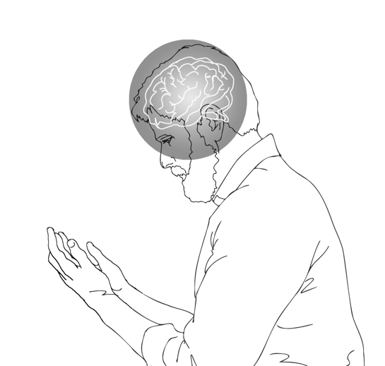

orthodoxy

In spite of these current tendencies, we should reaffirm that developing orthodox outlooks — a set of what we would call “true doctrines” — should be one of the chief goals of theology. We must always remind ourselves that in Jesus’ day there were many religions, and even many theological differences among the Jews. But despite the challenges that this diversity raised, Jesus insisted on the pursuit of orthodoxy. He spent much of his earthly ministry correcting falsehoods and teaching his followers what they should believe. He proclaimed, without hesitation, that his followers had to be people who sought truth.

Listen to Jesus’ prayer for his apostles in John 17:17:

Sanctify them in the truth; your word is truth (John 17:17).

Jesus was deeply concerned with true doctrine. Many today believe that we can be sanctified — set apart for God’s service — without learning true theological concepts. But Jesus prayed that the apostles would be sanctified by the truth of God’s word. He affirmed that orthodoxy is one of the principal goals of theology, and as his followers, we must do the same.

Now, as important as it is to affirm the primary goal of orthodoxy, Christians must also acknowledge the goal of orthopraxis.

Orthopraxis

As the word itself indicates, orthopraxis amounts to focusing on:

right behavior or practice

This term has moved to the foreground of many theological discussions in recent decades, especially among those who have taken up a life orientation toward theology. You’ll recall that William Ames described the marrow, or core of theology as the doctrine of “living to God.” One aspect of living to God is our practice or behavior. It’s not enough simply to *think* correctly about theological concepts. We must also put these concepts into practice. Here we have in mind specifically physical behaviors. For instance, in theology we learn that we are to pray, evangelize, worship, serve each other, and give generously to the poor. But learning about these and other truths is not enough for responsible Christian theology. These truths must be translated into proper *actions* — into orthopraxis.

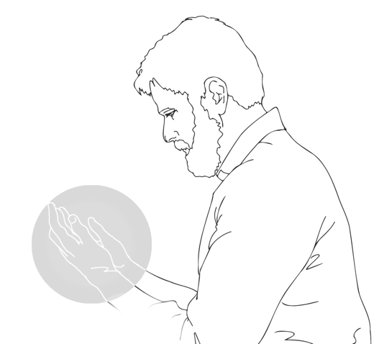

orthopraxis

The relationship between theology and orthopraxis, or the way in which that theology works itself out in our lives, is crucial in part because it’s not just about what we believe, but how what it is that we believe works itself out in our lives. You could think back to the early church, for example, about the Gnostics, and for the Gnostics it was all about just having this right belief, these secret understandings of God and his word and who Jesus was. And it didn’t matter how that worked itself out in one’s life because everything about this world, everything about this earth is accidental — there is no sense in which the behavior that relates to what one believes matters. But Christ doesn’t say that at all. In his own teachings, and in the writings throughout the rest of the New Testament, and indeed throughout the whole Old Testament, God is saying to his people, “You are my people, and as such, because we have this relationship, you are my emissaries to the world. What it is that you do reflects your relationship with me.” And so, it’s an inextricable bond between what we believe and how we behave, how we go about living that out, either in terms of ministry and those that are called to be leaders of a church or a ministry and how they shepherd the flock, or even those just within the church that are living out their faith in their own ministry calling that God has called them to in their work or life or school. What we believe and how that works itself out in our lives is absolutely an essential relationship.

— Dr. Scott Manor

Sadly, evangelicals face several enormous challenges in maintaining their interest in the theological goal of orthopraxis. First, people outside of the church constantly bombard us with the lie that there are no moral absolutes, that no behaviors are particularly good or bad. So, many of us grow weary of standing against the tide of our cultures by insisting that there are right and wrong ways to behave.

But even from within the church, some of our reticence to make orthopraxis a crucial goal stems from how we as Christians have failed in this endeavor in the past. The church has committed many sins in the name of truth. We look into the history of the church and see horrendous behaviors that were supported by serious theological reasoning. It’s a sad fact of history that religious people, even sincere Christians, often use their theology to justify all kinds of terrible sins.

But despite these serious difficulties, orthopraxis is still critical because our behavior still matters to God. Our good and bad works still affect our eternal rewards. The good things we do can also be God’s means of ministering to our fellow Christians. We can still present a powerful witness for Christ to the unbelieving world through proper behavior. For these and other reasons, orthopraxis must be an essential goal of theology.

Now we need to be cautious on many levels. Humility and love must characterize our behavior at every turn. And we mustn’t reduce Christian life to mere actions. Scripture is clear that we cannot earn our salvation through good works. Still, theology should never be concerned merely with conceptual correctness, but also with teaching and doing the right kinds of actions. Listen to James 2:19 where James warned against pursuing orthodoxy without orthopraxis:

You believe that God is one; you do well. Even the demons believe — and shudder (James 2:19).

In this passage James made a remarkable claim. In many respects, demons are orthodox. They believe that God is one. And they believe this truth so deeply that they “shudder” in fear. But the demons’ orthodoxy does them no good because they refuse to submit to God in their practices.

James is writing to Jewish Christians scattered abroad, and he picks up on their central confession of faith. He says, “Do you believe that God is one?” Well, that comes from the *Shema*, a prayer that they prayed every day from Deuteronomy. He says, “Well, if you believe that, you do well. But also, the devils believe and they tremble.” Well, what’s the difference between believing like the devils even believe and then faith that really means something, that actually saves us and creates a relationship with God? Well, the difference is in loving God and obeying God. James is focusing on not just reading the Word, not just hearing God’s words, not just embracing them in the idea, but following them, attaching our affections to God. Jesus said it this way, he said, “If you love me, you’ll keep my commandments.”

— Dr. Gregory R. Perry

In addition to the primary goals of orthodoxy and orthopraxis, we must also mention the goal of orthopathos.

Orthopathos

This terminology is not widely used, but it’s not difficult to understand. The term “orthopathos” means:

right or correct feelings or emotions

Living for God involves making sure that our deepest sentiments are used in his service. Our joys, our disappointments, our yearnings, our anger, our exhilaration and a host of other emotions must be brought into conformity with the will of God. Unfortunately, if academic theologians tend to overlook any goal of theology, it’s the goal of orthopathos. Neglect of the emotional dimension of theology occurs for at least two reasons.

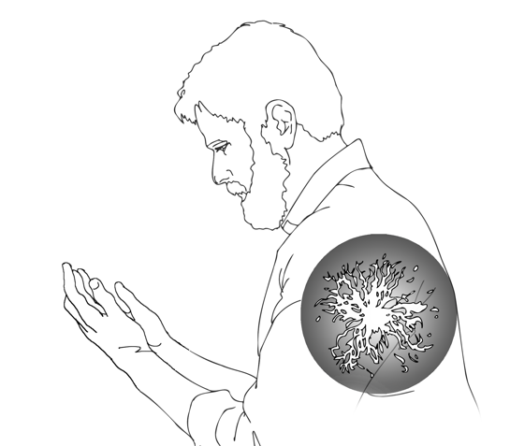First, many academic theologians are often psychologically inept at expressing or exploring emotions. In fact, the often-sterile academic model frequently influences people to take up careers in academic theology — becoming professors and teachers — so they can avoid confronting the emotional dimensions of life. Consequently, it’s not surprising to find about as little excitement, joy, pain, sympathy, care and love expressed in academic theological writings as you do in academic botany textbooks. If you’ve ever read much academic theology, you know that very little attention is given to emotional matters. Sadly, this occurs most often because professional theologians themselves do not value emotions, or they simply haven’t developed themselves emotionally.

orthopathos

A second obstacle to orthopathos is that many evangelicals have fallen into the trap of believing that feelings are amoral, or morally neutral. It’s not appropriate, they say, to speak of some feelings being right and others wrong. They believe that the notion of orthopathos — right feelings — is entirely misguided. But it’s interesting to note that as widespread as the amoral outlook on emotions may be, it is much more in line with certain modern psychological theories than it is with the Bible’s perspectives.

When you think about the fruit of the Spirit in Galatians 5 — love, joy, peace, patience, kindness, goodness, faithfulness, gentleness and self-control — when you think about those words, they’re *highly* emotional. And what this tells us is that the work of Holy Spirit in the life of the believer impacts the emotions. So, emotions are not morally neutral. There are good emotions, and there are bad emotions. There are righteous emotions, and there are evil emotions. Now, we often have a hard time distinguishing those in this situation and that situation, but the fact is, is that the more we think along the lines of what the Bible teaches us, the more we’ll be asking questions like, is my emotion correct for this situation? Is my feeling about this circumstance the way God wants me to feel about it? The fact that the fruit of the Spirit involves all kinds of emotional terms like kindness and gentleness and self-control and things like that — love, joy, peace, patience — I mean, what could be more emotional than those kinds of words? And the truth is, then, that emotions must be a part of Christian theology. When we think about the Bible and when we apply the Bible to life, it must impact our emotional lives. Not just our intellectual lives, not just our behaviors, but our emotions as well.

— Dr. Richard L. Pratt, Jr.

The Bible tells us a lot about how we’re to think about God, how we’re to act toward God, and also what we’re to feel about God. So, the Bible is very clear that emotions are not morally neutral. Emotions are one of the ways that we are to glorify God with the whole of who we are… I pray that every aspect of my emotional response to the Lord and my emotional response to my life and what happens in my life would reflect who God is, who he’s made me, and how he’s made me to respond to this broken world, but this world also that he’s redeeming and going to bring to fruition as he creates the new heavens and new earth.

— Dr. M. B.

A wonderful example of pathos within theological writing is found in the writings of the apostle Paul. We all know that Paul was concerned with orthodoxy. He was committed to pursuing the truth. Yet, time and again, as he wrote about truth, Paul could not contain his feelings. His reflections on orthodoxy caused spontaneous emotional outbursts. As just one example, listen to Romans 11:33-36 where Paul broke out in exuberant praise:

Oh, the depth of the riches and wisdom and knowledge of God! How unsearchable are his judgments and how inscrutable his ways! “For who has known the mind of the Lord, or who has been his counselor?” “Or who has given a gift to him that he might be repaid?” For from him and through him and to him are all things. To him be glory forever. Amen (Romans 11:33-36).

Now when was the last time you read something like that in the middle of an academic theological treatise?

The book of Romans, in the first 11 chapters, teaches us all the depth of who God is and what he has done. In each chapter, Paul is adding something more, and when you get to chapter 11, at the end of chapter 11, the apostle is expressing all that greatness of what he has known of God… When you come to know God in that way, as he did — that merciful, loving, just, good, powerful God — you cannot avoid coming to a physical, spiritual, total worship in your being, a grand expression, an awesome expression of worship of God, because you recognize and understand who he is.

— Rev. Pablo Torres, translation

Now that we’ve identified three primary goals of theology, we should comment on their interdependence. This interdependence is an important reason why we can’t ignore any one of these goals. In fact, they are so intertwined that we can’t be strong in one area without being strong in the other two.

Interdependence

We’ll look at this interdependence in three ways. First, we’ll see some of the ways orthodoxy impacts the other two goals of theology. Then we’ll note how orthopraxis affects both orthodoxy and orthopathos. And third, we’ll consider how orthopathos influences the goals of orthopraxis and orthodoxy. Let’s look first at the ways orthodoxy, or right thinking, impacts our behaviors and emotions.

Orthodoxy

Most evangelicals today rightly believe that some measure of orthodoxy is necessary for orthopraxis and orthopathos to occur. We learn from many academic and popular theologians that we must first understand the truth, and *then* apply it to our lives. It’s quite common for Christians to operate with a rather straightforward perspective on these matters: “What I believe will determine how I live.” And this is certainly true. What we believe to be true deeply influences our behaviors and our emotions.

At times, as our orthodoxy develops, what we come to believe will *confirm* our behaviors and emotions. Perhaps you’re a person who’s naturally inclined to feel sympathy for others and to act on those feelings. As you study theological concepts like humanity as the image of God and the kindness and mercy of God himself, you’ll find that the deepening of your orthodoxy will confirm and enhance your behaviors and emotions.

At the same time, however, orthodox theological concepts often *challenge* us to change our behaviors and feelings. Perhaps you’re a person who struggles with selfishness and greed. You’re indifferent to the poor, and you do nothing to help relieve their suffering. Then, as your theological concepts of humanity and God become more orthodox, you will find it necessary to change your behaviors and emotions. Pursuing orthodoxy impacts orthopraxis and orthopathos in these and countless other ways.

Orthodox beliefs — that is, right beliefs — impact and should impact our emotions and our actions and our life because what we believe should be expressed in our lives. And we are called not to live to be transformed in our minds but also in our emotions. And what we believe should inform our lives. The information that we have through our beliefs, by the grace of God and the work of the Holy Spirit, should transform us and eventually to form us so that our affections are really according to the will of God and our actions are also according to his revealed in the Word of God. And that is possible only by the enabling grace of the Holy Spirit.

— Dr. David Samuel

Now let’s turn to a second way the goals of theology are interdependent. How does orthopraxis influence orthodoxy and orthopathos? How do our behaviors affect our beliefs and our emotions?

Orthopraxis

In the first place, orthopraxis often confirms or challenges what we believe to be true. For instance, consider what happens when inexperienced students of theology are asked, “Why should Christians pray?”

All too often, when believers don’t have much experience of God answering their prayers, they respond to this question with something like, “We should pray because God commanded it.” Now, this answer is true, as far as it goes. But I’ve never heard a prayer warrior — someone who is known for having an extensive, fully developed prayer life — answer in this way. It’s true that the Bible teaches us to pray because we’re commanded to, but a lack of prayer experience often hinders us from seeing many other biblical motivations for prayer. So, our *practice* of prayer influences what we understand to be true about prayer.

When believers are more experienced in prayer, they’re often able to see more clearly all kinds of reasons the Bible gives us to pray. We pray because God is worthy of our prayers. We pray because we need him. We pray because, well, as James said in James 5:16:

The prayer of a righteous person has great power as it is working (James 5:16).

Righteous behavior and the experience of prayer yield the true insight that prayer is not only commanded; it’s also powerful and effective. A lack of godly behavior robs us of these theological beliefs. But the experience of holy living challenges, confirms, and enhances our beliefs in many ways.

Beyond this, our actions also influence the emotional dimensions of our theology. That is to say, orthopraxis impacts orthopathos. For example, when believers commit serious sins, they often go through the emotional experience of guilt and conviction. At the same time, when we do what is right, we often find the joy and pleasure of God’s approval and blessing. We all know from common experience that feelings of shame and sadness, confidence and calm, joy and excitement often result from our behaviors.

Recently there was a crisis in an institution in which I serve as the president of the board. There were some people coming from outside with some vested interest, especially from other religions, trying to create trouble in the institution. So, there was an option that we really compromise with them, but we stood firm and decided that we will do the right thing and will not make compromises for the sake of false peace. And God honored our stand for him, and we were delivered from all those enemies, and it has really led to great joy energizing the community.

— Dr. David Samuel

As we’ve seen, orthodoxy — holding to true theological concepts — affects what we do and feel. And orthopraxis — behaving as truth requires — affects what we feel and believe. Now let’s take one more look at the interdependence of the goals. How does our orthopathos — our right emotions and attitudes — influence what we believe and do?

Orthopathos

I think everybody understands from daily experience that the way we think about things impacts our emotions. And we also understand that when we do certain things, that also has an emotional impact. But sometimes we don’t consider just how much emotions feed back into the ways we think and the ways we behave. And when you do Christian theology, it’s very important to keep that direction of influence in mind also. I mean, think about it this way, when you’re discouraged, you’re just not motivated much to delve into complicated ideas. So, your emotions are impacting the way you think about things. Or we could put it this way, your orthopathos, your pathos, is impacting your orthodoxy. But on the other side, if you’re optimistic in a situation, then you’re ready to tackle all kinds of intellectual problems and issues and ideas, and so once again your emotions are impacting the way you think. This is so very important, and every teacher know this, that one of the critical things in teaching is the motivation or the emotions of the student and how that impacts the way they think, even the way they learn about things. And this is true all through Christian theology. And at the same time, emotions also impact our actions. When we’re bewildered, it’s hard to do the right thing. It’s just that simple. And it’s true for Christians when they do Christian theology that when they start drawing out the implications of the Bible for their orthopraxis, the ways they live, the ways they behave, if they’re tired and bewildered and discouraged, they’re just not going to have the energy for doing the right thing. But the flip side of that is that if you’re encouraged, something’s happened that’s made you feel good and strong, then you find that you’ll do what you ought to do more readily. I just think that’s very important to us because even in the Bible, when the Lord calls his people to obey him, he often gives them motivations for why they should obey him. He calls them to rejoice and to reflect on the good things that have happened, or the bad things that have happened. And that emotional impact then leads them into obedience to God. So, as important as it is to realize that our emotions are affected by the ways we think and the ways we act, it’s also just as important to realize that our emotions impact how we think and how we behave. So, all of these are critical to the process of studying Christian theology.

— Dr. Richard L. Pratt, Jr.

We find some of the best examples of orthopathos in the Psalms. Time and again, the psalmists’ emotions moved their thinking and actions in one way or another. For instance, when a psalmist felt forsaken, his expressions of orthodox thinking focused primarily on the trials he underwent and how his faith in God factored into this suffering. Listen to Psalm 13:1-3 and the way the psalmist’s sorrow pressed him to ask perplexing theological questions. He pleaded:

How long, O Lord? Will you forget me forever? How long will you hide your face from me? … Consider and answer me, O Lord my God (Psalm 13:1-3).

In much the same way, the psalmists’ emotions also influenced their *actions.* When forlorn, the psalmists were not quietly passive. Instead, they wept profusely; they grew sick. As the psalmist put it in Psalm 6:6:

I am weary with my moaning; every night I flood my bed with tears; I drench my couch with my weeping (Psalm 6:6).

At the same time, when the psalmists were joyful, they displayed this feeling with the behaviors of dance and praise. As we read in Psalm 30:11:

You have turned for me my mourning into dancing; have loosed my sackcloth and clothed me with gladness (Psalm 30:11).

Good theology will be concerned not only with the intellectual or the outward working of the Christian faith in our actions, but what is sometimes called orthopathos, in other words, our emotional reaction to the truth of God’s Word. And I think that it’s important that the truth shouldn’t just remain at the cognitive and intellectual level because it impacts who we are as human beings. And anything that we truly love or believe in incites in us emotions and affections and feelings, and that sort of “pathos” side of our humanity is part of the true outworking of the Spirit of God when we’ve grasped the truth of God.

— Dr. Simon Vibert

All of this is to say that the three goals of orthodoxy, orthopraxis and orthopathos do not operate apart from each other. They are highly interdependent. As we build our theology, we must always keep in mind that what we believe impacts our actions and attitudes. Our practices influence our beliefs and emotions. And our emotions affect our beliefs and actions as well.

Understanding the interdependence of the three primary goals of theology raises a critical issue. What priorities should we observe as we pursue the goals of theology? Should we concentrate more on orthodoxy, orthopraxis or orthopathos?

Priorities

We all know that Christians can be very different from each other in many ways. Some of these differences stem from the personalities God has given us. Other differences come from our various circumstances. Still others derive from the supernatural work of the Holy Spirit within us. God designed the body of Christ to be diverse in these and many other ways. And in many respects, our diverse personalities, circumstances or the special work of the Spirit of God within us, can affect how we prioritize the three primary goals of theology. Not surprisingly, we all tend to favor one or two goals more than the others. But is there one *correct* set of priorities that every Christian should follow? Is there one right way to approach orthodoxy, orthopraxis and orthopathos?

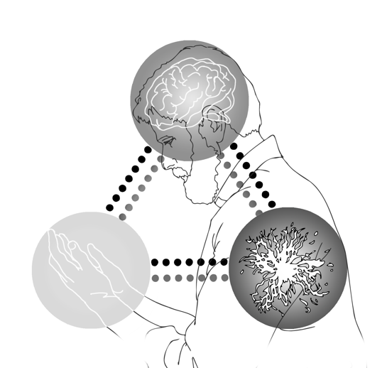

orthodoxy

orthopraxis

orthopathos

Many evangelicals have a simple answer to this question. They insist that we should always give first place to orthodoxy, second place to orthopraxis and third place to orthopathos. As we often hear, “Think right; then do right; and then you’ll feel right.”

Now, it’s true that orthodoxy can lead to orthopraxis, and orthopraxis can lead to orthopathos. But a problem arises when we follow these priorities *all* the time. Most often, we never get beyond the first step. We’re so focused on orthodoxy that we neglect our theology of action and pathos, or at best we consider these other goals secondary. Unfortunately, because of these goals’ interdependence, when we give little attention to our behaviors and emotions, we also diminish our orthodoxy.

Thoughts, actions and emotions in theology interconnect with each other like the vital systems of the human body. Our bodies have a number of vital systems: a central nervous system, a digestive system, a cardiovascular system, and so on. Now, which of these systems should be given priority? What is the proper order for managing the interconnections among these systems? We may think about how the nervous system affects the digestive system, but we may also think about how the digestive system affects the nervous system. There are many legitimate and useful ways of working our way through these interconnections.

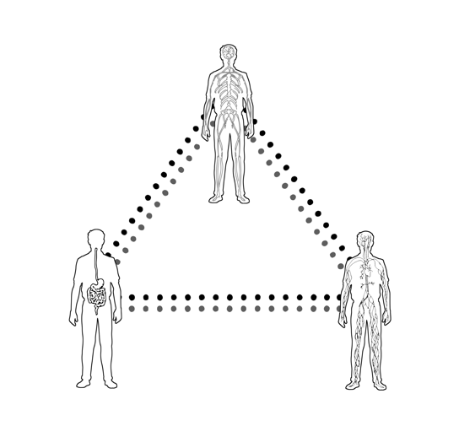

nervous

digestive

cardiovascular

In much the same way, we’ve seen that our pursuits of orthodoxy, orthopraxis and orthopathos form webs of multiple reciprocities. That is to say, they all influence each other in countless ways. Rather than simply being linear in their relationships, they are multi-linear, or reciprocal, to the point that we can’t always assign one priority. It’s true that we should think rightly so that we can do rightly and then feel rightly. But at times we should also do the right thing so that we can think the right way and feel the right way. And sometimes, we should even feel the right way so that we can think and do correctly. The Holy Spirit leads his people toward the goals of theology in many different ways.

I would say the relationship between orthodoxy, orthopraxis, orthopathos is at the core of a Christian understanding of the human person and redemption and conformity to the image of Christ … our beliefs, and what we do, and our desires all coming together and acting as one, as a sign of and as an element of our restoration and redemption. And so, this is what Paul understands as a fundamental goal of and product of the gospel, that we are the ones who actually are freed by the love of God to obey God and to love others and to do that from the heart. And that’s exactly what Jesus commands on the Sermon on the Mount. You know, Jesus says, “Your righteousness has to be better than the scribes and the Pharisees,” which means you need to do the right things, but don’t do it for hypocritical, legalistic motivations. Do it from the heart. And so, Jesus sees that as the fundamental fruit of the gospel of what salvation is and brings to our humanity.

— Dr. Jeff Dryden

How then do we decide what to do? How do we decide whether to stress right thinking, doing or feeling? The answer is that we must develop the wisdom to give priority and emphasis to the goals of theology that are needed most in any given situation.

In many ways, it helps to think of balancing the goals of theology as if we are maintaining our balance on the deck of a rocking ship. Because the deck of life is always shifting, balance can be nothing more than momentary synchronicity. To stand on a shifting deck, we have to lean one way and then another over and over. If we fail to adjust to the needs of the moment, we’ll surely fall overboard.

In much the same way, as we build our theology we have to ask ourselves which goal of theology we need to emphasize in each circumstance. “What theological goal do I need to stress at this moment?” “What do others around me need most right now?” “Should I give priority to right thinking, to right behavior or to right emotions?” “Should I stress orthodoxy, orthopraxis or orthopathos?” Then we establish the appropriate orientation for that time, and we pursue all the goals of theology with all of our hearts.

Much harm can come to us as individuals, and to others around us, if we don’t learn how to shift our priorities. If we constantly pursue orthodoxy as our top priority, we easily neglect the other goals of theology and stumble into intellectualism. If we constantly emphasize orthopraxis to the neglect of the other goals of theology, we easily fall into legalism. And if we always stress orthopathos to the neglect of the other goals of theology, we easily fall into emotionalism. But learning how to balance these goals, as the deck of life turns one way or the other, can help us avoid these extremes. So, each of us needs to ask the question, “Which of these tendencies characterizes the way that I approach theology? Am I prone toward intellectualism? Am I prone toward legalism or emotionalism or some combination of these?” Whatever our natural tendencies may be, we need to work hard to focus on those goals of theology that we tend to ignore. Then we’ll be able to build a theology that leads to the glory of God and to our unending enjoyment of him.

I think it’s important to remember that God created the totality of the person, not just their mind but created humans as emotive beings and as thinking beings and as acting beings. So, when Jesus tells us we’re to love the Lord God with all our heart, mind, soul and strength, it’s with the totality of the person. And I think that one of the ways to avoid an extreme in one area is to seek to love God in all dimensions of the human person. So, in other words, if someone is very emotional in their love of God, crying and ecstatic, this person needs to be rooted in deep-thinking of Scripture. In 1 Corinthians 14, God tells us through Paul, Paul tells us that God is not a God of disorder but a God of peace and that where God’s Spirit reigns, there’s an order in the worship of the church. And so, where that is lacking, I think that reflects the community is not living in accord with God’s revelation. They need to be instructed. They need to learn. There needs to be intellectual learning and growth that then results in a balanced expression — joy, emotion, passion, but not out of control out of control behavior.

— Dr. Robert L. Plummer

Now that we’ve looked into the definition and goals of Christian theology, we should turn to a third issue, the topics or subjects that comprise theology as a formal field of study.

TOPICS

Introducing someone to the theological enterprise is like introducing someone to the universe. It’s a daunting task to say the least. So, in these lessons, we’ll have to narrow our focus in theology to just a few topics.

To understand the topics that will interest us, we’ll touch on two matters: first, the many options before theologians; and second, the selections we’ll make in *these* lessons. Let’s look first at the options that await anyone who ventures into the formal study of theology.

Options

When people first enter the serious pursuit of theology, they’re often overwhelmed by the large scope of the field. It’s common to think of theology as covering a long list of subjects. Throughout the two millennia of the Christian faith, a number of topics have come to occupy those who focus much attention on theology. The list of subjects differs from one branch of the church to another, but there are enough similarities that we can name a number of major theological categories.

The pursuit of theology normally includes some relatively practical topics like:

* missions
* evangelism
* apologetics — or defending the faith
* worship
* mercy ministries
* pastoral counseling, and
* homiletics — or preaching

It also includes a vast array of more theoretical or abstract subjects like:

* soteriology — the doctrine of salvation
* ecclesiology — the doctrine of the church
* anthropology — the doctrine of humanity
* pneumatology — the doctrine of the Holy Spirit
* Christology — the doctrine of Christ
* theology proper — the doctrine of God
* eschatology — the doctrine of end times
* biblical theology — theology of redemptive history recorded in the Bible
* systematic theology — the logical arrangement of biblical teaching
* historical theology — tracing the development of doctrines in the history of the church, and
* hermeneutics — or interpretation

Now for the most part, traditional academic theology has focused on these topics primarily from the vantage point of orthodoxy, or the right way of thinking about these matters. A typical seminary class on any of these subjects will concentrate on getting the concepts straight — making sure that everyone is thinking properly. Occasionally, some seminary classes will concentrate on learning skills. Classes that focus on worship, evangelism, counseling, and homiletics — preaching — normally have a significant concern for skills or orthopraxis. Unfortunately, it’s not common for seminary classes to concentrate on orthopathos, or the emotional dimensions of theology, even in a homiletics class. Yet, as we’ve learned in this lesson, a more adequate approach to the topics of theology requires deepening our concern in all three directions. So, we can see that the task before a student of theology is colossal. With every topic of theology, there are countless directions to pursue.

As you might imagine, the long list of topics and the many options that we face when building our theology leads to the necessity of making selections. We have to choose the topics and the emphases that we will pursue.

Selections

Everyone who builds houses will tell you that it’s good to learn from what others have done. But at the same time, builders must also determine what it will take to complete their own projects. Well, in many ways, the same is true for us as we build Christian theology. It’s good to learn from other followers of Christ. There’s much to learn from the topics they’ve identified and how they’ve handled those topics. But at the same time, each of us must still determine what it will take to build our *own* theology — theology that furthers our service to God.

There’s a grave danger that new students of theology face. The number and complexity of theological topics can be overwhelming. In fact, the field is so large that many students can do little more than barely learn the raw data of these topics. As a result, students often find themselves focusing almost exclusively on orthodoxy because there’s so little time to explore other dimensions.

Well, in these lessons we want to avoid becoming overwhelmed by the vast array of theological topics. So, rather than trying to introduce the entire encyclopedia of theology, we’re going to limit ourselves to just a few, select subjects. As we move forward, we’ll concentrate on the aspects of theology that we’ll call pastoral theological concerns. What we mean by this is those sets of beliefs, practices, and pathos that are more directly beneficial for pastors and church leaders. We’ll be asking ourselves questions like: How do people training for church leadership need to approach the study of theology? What do they need to know? What do they need to do? And what do they need to feel theologically?

Happily, we don’t have to invent answers to these questions. The church has already pointed in several important directions. As theological education has developed over the centuries, a consensus has grown among a variety of denominations throughout the world. Today, there’s general agreement on the kinds of topics that need to be covered when educating leaders in the church.

When it comes to discussing which theological topics are important in developing Christian leaders, one can think of any number of them. First of all, the Bible, from the Old Testament to the New, is all about God’s kingdom and holy covenant. There are also the traditional topics of systematic theology, such as theology proper, Christology, pneumatology, anthropology, eschatology and so forth. Of course, there are even more relevant topics such as practical theology and church history. For me, as someone who especially focuses on the development of church leaders, they need to know how to evangelize, pray, and have the gift of teaching. Evangelism in particular isn't just a matter of teaching a crowd, but a church leader has to lead disciples just as Jesus did with the Apostles. The scope involved here is quite broad.

— Dr. Biao Chen, Translation

A typical seminary curriculum is often divided into three major divisions that look something like this: the biblical division; the doctrinal and historical division, and the practical division. These three divisions represent major ways the Holy Spirit has led the church to develop theological education for its leaders. Let’s unpack each area starting with the biblical division.

The biblical division normally divides into Old Testament studies and New Testament studies. These areas of the curriculum focus on the content of Scripture and expose future church leaders to responsible interpretation of the Bible. The doctrinal and historical division often divides into church history and systematic theology. Church history focuses on how God has developed theology in the church as the body of Christ has struggled against the world in different ways at different times. Systematic theology exposes students to the ways the church has organized the teaching of the Bible into logical or systematic arrangements. Finally, the practical division draws attention to students’ personal spiritual development and practical ministry skills such as preaching and evangelism.

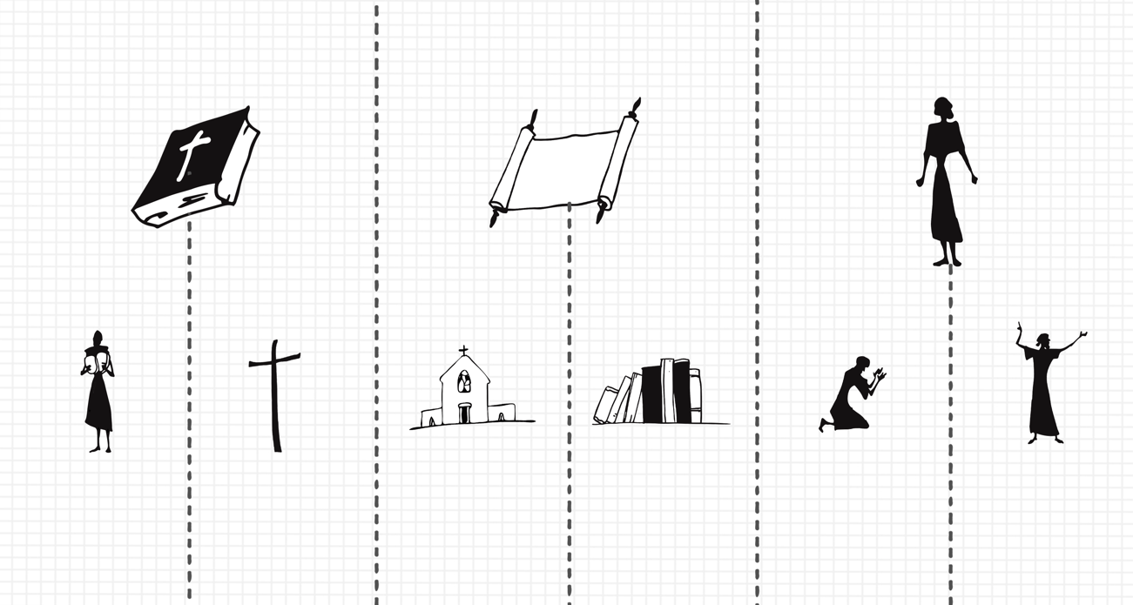

Biblical

Old

Testament

Doctrinal and Historical

Practical

New

Testament

Church

History

Systematic

Theology

Spiritual

Development

Practical

Ministry

As we progress through this series of lessons, we’ll acknowledge the important contours of these theological divisions. We’ll look into the ways each of these areas of theology function and how they work together as we pursue theology. In addition, we’ll keep all three of our theological goals in mind as we study each division. We’ll not only focus on orthodoxy, but on orthopraxis and orthopathos as well. And in this way, we’ll work toward building a responsible Christian theology.

CONCLUSION

In this lesson we’ve explored the most basic question we can ask as we venture into theology, namely, “What is theology?” We’ve touched on three aspects of this question: the definitions of theology, the goals of theology and the topics of theology.

It’s the privilege and responsibility of every follower of Christ to build theology. And as we’ve seen in this lesson, doing this in a formal way presents both challenges and opportunities. We must be mindful to avoid paths that harm how we think, act and feel about the Christian faith. And we must do all we can to pursue theology in ways that enhance how we think, act and feel as servants of Christ. The issues we’ve addressed in this lesson are so basic that they will impact this entire series of lessons on *Building Your Theology*. And by God’s grace, we’ll be better equipped to build theology that honors Christ and furthers his kingdom in our personal lives and in the church throughout the world.

CONTRIBUTORS

**Vincent Bacote, Ph.D. (Host)** is Associate Professor of Theology and Director of the Center for Applied Christian Ethics at Wheaton College. Dr. Bacote holds an M.Div. from Trinity Evangelical Divinity School with an emphasis on Urban Ministry, and an M.Phil. and Ph.D. in Theological and Religious Studies from Drew University. He is a member of the American Academy of Religion, the Christian Theological Research Fellowship and the Evangelical Theological Society. A prolific writer and speaker, Dr. Bacote has authored and edited numerous books, including *The Spirit in Public Theology: Appropriating the Legacy of Abraham Kuyper* (Baker Academic, 2005) and *The Political Disciple: A Theology of Public Life* (Zondervan, 2015). He is also a regular columnist for *Comment* and has contributed to magazines such as *Books and Culture*, *Christianity Today*, and *Think Christian*. He and his family reside in the Chicago area.

**Rev. Azar Ajaj** is Director of Public Relations and Lecturer at Nazareth Evangelical College in Nazareth, Israel.

**Rev. Dr. Humphrey Akogyeram** is a professor at Good News Theological Seminary in Accra, Ghana.

**Dr. M. B.** is professor at Bethlehem College and Seminary.

**Dr. Biao Chen** is Director of Chinese Projects at Thirdmill.

**Dr. James K. Dew, Jr.** is Assistant Professor of the History of Ideas and Philosophy at Southeastern Baptist Theological Seminary.

**Dr. Jeff Dryden** is Professor of Biblical Studies at Covenant College.

**Rev. Hutch Garmany** is Pastor and Church Planter of Grace Community Trenton in Trenton, Georgia.

**Dr. Kelly M. Kapic** is Professor of Theological Studies at Covenant College.

**Dr. Scott Manor** is Assistant Professor of Historical Theology, Vice President of Academic Affairs, and Dean of Faculty at Knox Theological Seminary.

**Dr. Gregory R. Perry** is Vice President for Strategic Projects at Thirdmill and former Associate Professor of New Testament and the Director of City Ministry Initiative at Covenant Theological Seminary.

**Dr. Robert L. Plummer** is Associate Professor of New Testament Interpretation at The Southern Baptist Theological Seminary.

**Dr. Richard L. Pratt, Jr.** is Co-Founder and President of Thirdmill.

**Dr. David Samuel** is Director of the Association for Theological Education by Extension in Bangalore, India.

**Rev. Pablo Torres** is Pastor of Iglesia La Viña in Orlando, FL.

**Dr. Larry Trotter** is Pastor of Florida Coast Church in Pompano Beach, FL, an adjunct professor at Knox Theological Seminary, and formerly, the country director for Mission to the World in Mexico.

**Dr. Simon Vibert** is Senior Pastor of Christ Church Virginia Water, England, and the former Vice Principal and Director of the School of Preaching at Wycliffe Hall, Oxford.

GLOSSARY

**Ames, William** – (1576-1633) Influential Puritan theologian and author of *The* *Marrow of Theology*

**anthropology –** Theological term for the study or doctrine of humanity

**apologetics –** Field of study concerned with the systematic defense of Christianity

**Aquinas, Thomas** – (ca. 1225-1274) Italian theologian and Dominican friar who wrote *Summa Theologica*

**biblical theology –** Theological reflection drawn from the historical analysis of acts of God reported in Scripture

**Christology –** The study and doctrine of the person and work of Jesus Christ

**doctrine –** A synthesis and explanation of biblical teachings on a theological topic

**ecclesiology –** The study or doctrine of the church

**emotionalism –** A disproportionate and often excessive focus on the emotions

***ergates*** – Greek term (transliteration) meaning “a worker” or “a laborer”

**eschatology –** The study or doctrine of the last days

**Frame, John** – (1939- ) Contemporary theologian and professor; author of *The Doctrine of the Knowledge of God*, and several other titles

**hermeneutics –** The study of interpreting the meaning and significance of Scripture

**historical theology** – A theological discipline that traces the development of theological doctrines in the history of the church

**Hodge, Charles** – (1797-1878) Well-known theologian from Princeton Theological Seminary who wrote numerous commentaries, articles and books, including his three-volume *Systematic Theology*

**homiletics** – The art or craft of preaching

**intellectualism** – A disproportionate focus on the intellect without regard to emotional or behavioral considerations

**legalism –** A disproportionate focus on or adherence to keeping the moral law without regard to faith or the gospel of Christ

***logos*** – Greek term (transliteration) meaning "word" or "study"; title assigned to Christ (John 1:1)

**orthodoxy** – Right or straight thinking

**orthopathos** – Right or correct feelings or emotions

**orthopraxis** – Right behavior or practice

**pneumatology –** The doctrine of the Holy Spirit

**practical theology** – Theology that is applied to the daily lives of believers

**soteriology –** The doctrine of salvation

***Summa Theologica* –** The most famous work of Thomas Aquinas; written from approx. 1265-1274 as an instructional manual for beginning students of theology

**systematic theology –** A theological discipline that seeks to give a rational and orderly presentation of the doctrinal truths of Christianity

**theology** – Any matter that refers directly to God or that describes subjects in relation to God

**theology** **proper** – The doctrine or study of God; any theological matter that refers directly to God

***theos*** – Greek word (transliteration) for "God"

**webs of multiple reciprocities** – Manifold logical connections among various beliefs or systems